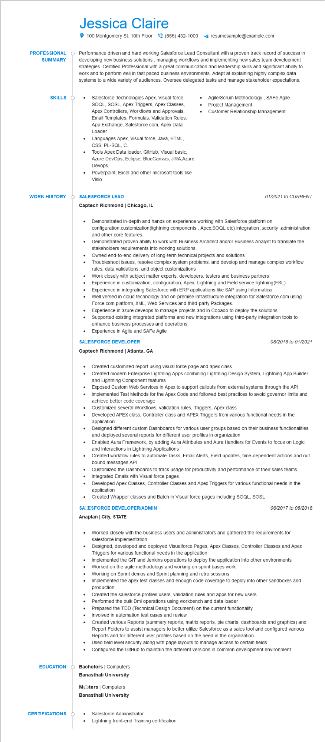
PROFESSIONAL
SUMMARY
SKILLS
Jessica Claire
100 Montgomery St. 10th Floor(555) 432-1000 4 resumesample@example.com
Performance driven and hard working Salesforce Lead Consultant with a proven track record of success in developing new business solutions, managing workflows and implementing new sales team development strategies. Certified Professional with a great communication and leadership skills and significant ability to work and to perform well in fast paced business environments. Adept at explaining highly complex data systems to a wide variety of audiences. Oversee delegated tasks and manage stakeholder expectations.
Salesforce Technologies Apex, Visual force, SOQL, SOSL, Apex Triggers, Apex Classes, Apex Controllers, Workflows and Approvals, Email Templates, Formulas, Validation Rules, App Exchange, Salesforce.com, Apex Data
Loader
Languages Apex, Visual force, Java, HTML, CSS, PL-SQL, C.
Tools Apex Data loader, GitHub, Visual basic, Azure DevOps, Eclipse, BlueCanvas, JIRA,Azure Devops.
Powerpoint, Excel and other microsoft tools like Visio
Agile/Scrum Methodology, SAFe Agile Project Management
Customer Relationship Management
WORK HISTORY O
SALESFORCE LEAD
Captech Richmond | Chicago, IL
01/2021 to CURRENT
•
Demonstrated in-depth and hands on experience working with Salesforce platform on configuration,customization (lightning components, Apex, SOQL etc) integration,security,administration and other core features.
Demonstrated proven ability to work with Business Architect and/or Business Analyst to translate the stakeholders requirements into working solutions.
Owned end-to-end delivery of long-term technical projects and solutions
Troubleshoot issues, resolve complex system problems, and develop and manage complex workflow rules, data validations, and object customizations
Work closely with subject matter experts, developers, testers and business partners
Experience in customization, configuration, Apex, Lightning and Field service lightning(FSL)
Experience in integrating Salesforce with ERP applications like SAP using Informatica
Well versed in cloud technology and on-premise infrastructure integration for Salesforce.com using Force.com platform, XML, Web Services and third-party Packages.
Experience in azure deveops to manage projects and in Copado to deploy the solutions Supported existing integrated platforms and new integrations using third-party integration tools to enhance business processes and operations.
Experience in Agile and SAFe Agile
SACESFORCE DEVELOPER
08/2018 to 01/2021
Captech Richmond | Atlanta, GA
.
Created customized report using visual force page and apex class
Created modern Enterprise Lightning Apps combining Lightning Design System, Lightning App Builder and Lightning Component features
Exposed Custom Web Services in Apex to support callouts from external systems through the API
Implemented Test Methods for the Apex Code and followed best practices to avoid governor limits and achieve better code coverage
•
Customized several Workflows, validation rules, Triggers, Apex class
• Developed APEX class, Controller class and APEX Triggers from various functional needs in the application
•
Designed different custom Dashboards for various user groups based on their business functionalities and deployed several reports for different user profiles in organization
Enabled Aura Framework, by adding Aura Attributes and Aura Handlers for Events to focus on Logic and Interactions in Lightning Applications
Created workflow rules to automate Tasks, Email Alerts, Field updates, time-dependent actions and out bound messages API
Customized the Dashboards to track usage for productivity and performance of their sales teams
• Integrated Emails with Visual force pages
Developed Apex Classes, Controller Classes and Apex Triggers for various functional needs in the application
Created Wrapper classes and Batch in Visual force pages including SOQL, SOSL
SACESFORCE DEVELOPER/ADMIN
Anaplan | City, STATE
06/2017 to 08/2018
Worked closely with the business users and administrators and gathered the requirements for salesforce implementation
•
Designed, developed and deployed Visualforce Pages, Apex Classes, Controller Classes and Apex Triggers for various functional needs in the application
Implemented the GIT and Jenkins operations to deploy the application into other environments
Worked on the agile methodology and working on sprint bases work
Working on Sprint demos and Sprint planning and retro sessions
Implemented the apex test classes and enough code coverage to deploy into other sandboxes and production
Created the salesforce profiles users, validation rules and apps for new users Performed the bulk Dml operations using workbench and data loader
Prepared the TDD (Technical Design Document) on the current functionality
Involved in automation test cases and review
Created various Reports (summary reports, matrix reports, pie charts, dashboards and graphics) and Report Folders to assist managers to better utilize Salesforce as a sales tool and configured various Reports and for different user profiles based on the need in the organization
Used field level security along with page layouts to manage access to certain fields
•
Configured the GitHub to maintain the different versions in common development environment
EDUCATION
Bachelors | Computers
Banasthali University
Moters | Computers Banasthali University
CERTIFICATIONS
Salesforce Administrator
Lightning front-end Training certification

